**Question 1**

**Part A**

**Part B**

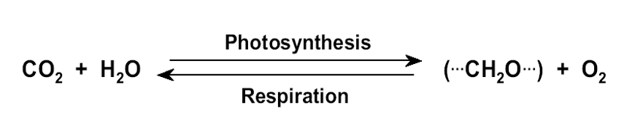

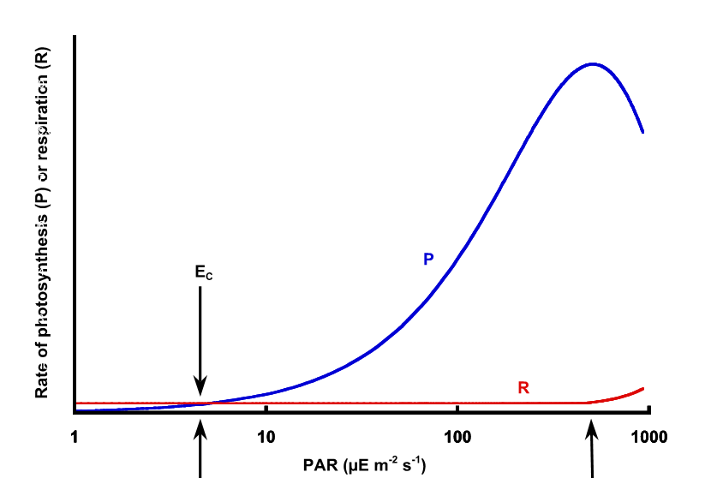

**Question 2**

**Part A**

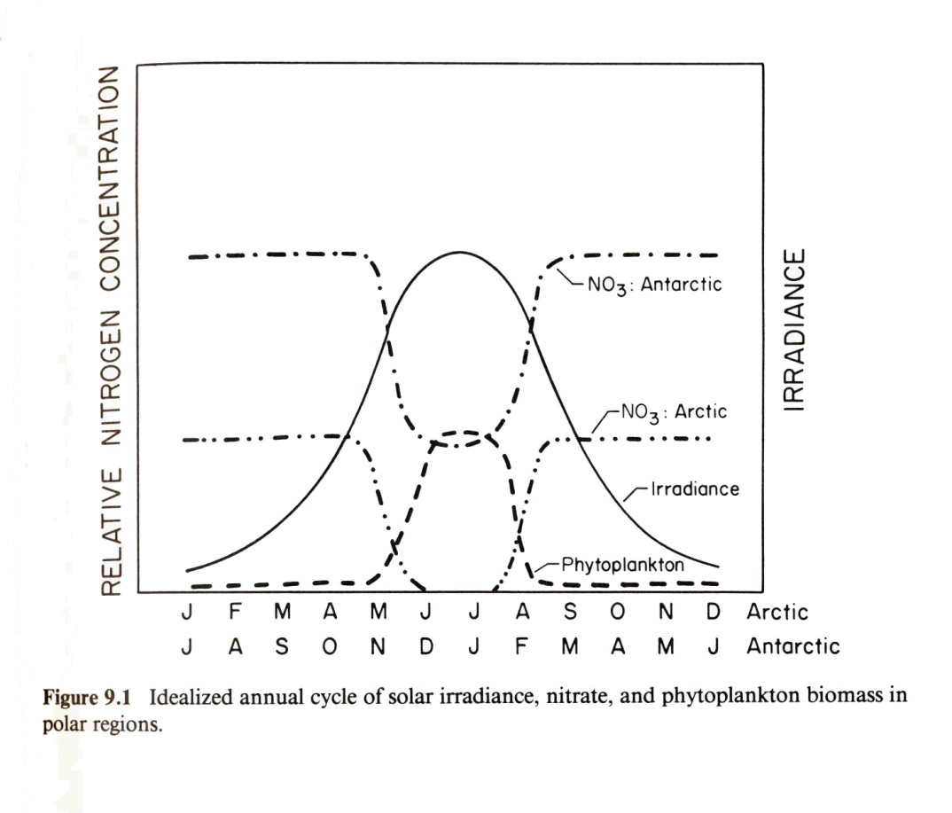

**Part B**

**Part C**

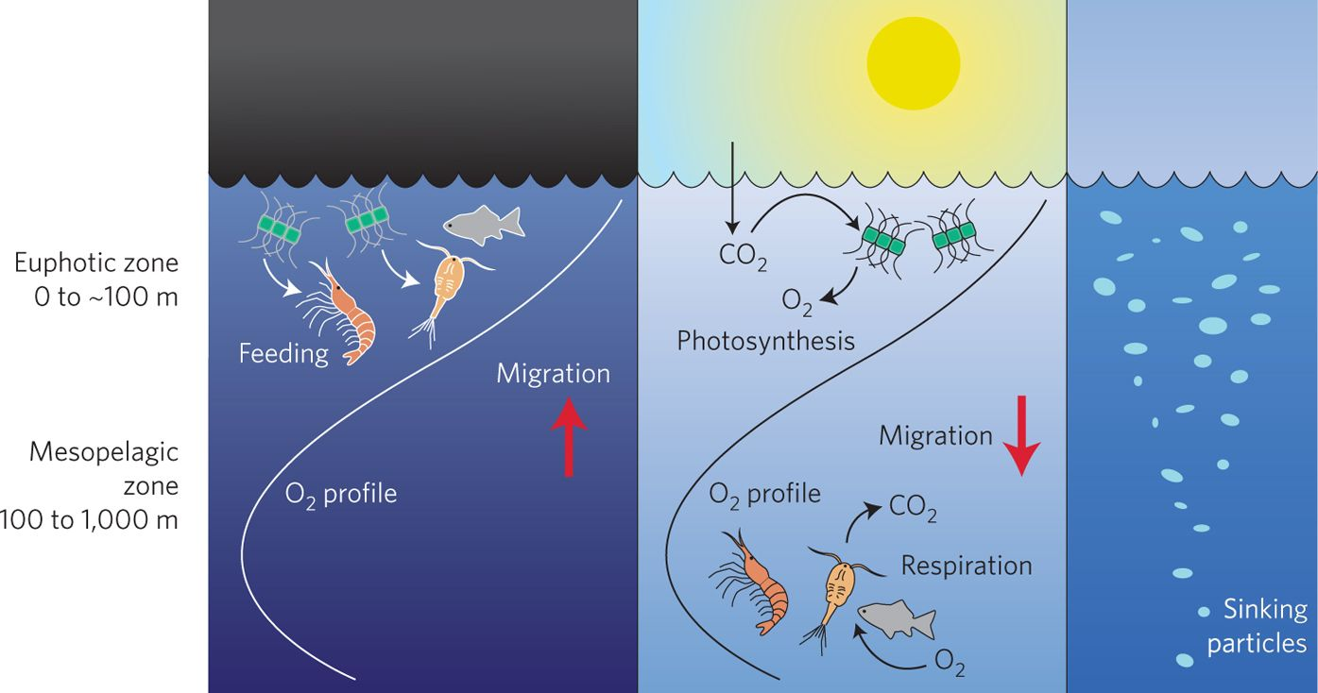

**Question 3**

**Part A**

**Part B**

**Part C**

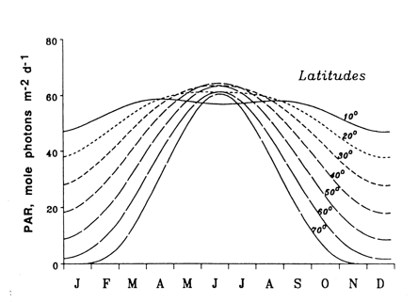

**Question 4**

**Part A**

**Part B**

**Citations**

Hill, M.N. (2005). *Physical Oceanography*. Harvard University Press. p. 499.

**BACKUP**

**Question 1**

**Part A**

**What is meant by Decoupling**

    The concept of “decoupling” can have different meanings depending on which scientific concept you are working with. In this case we are defining “decoupling” in reference to biogeochemical cycles. Some of these important cycles include the water cycle, nitrogen cycle and phosphorus cycle but we will focus on the carbon cycle. The two main components of the carbon cycle are respiration and photosynthesis. In a broad sense “decoupling” is a concept to look at biological processes that are normally intimately linked together as separate processes. Decoupling allows us to understand how humans can intake matter at a greater rate than their metabolic respiration and enable growth. In the pelagic environment decoupling is responsible for the enabling of the food web through the primary photoautotrophic producers.

**Part B (**I will elaborate on either)

**Example of Decoupling**

    An example of “decoupling” in marine ecology would be the Spring Blooms that occurs in temperate coastal areas and the subarctic North Atlantic. Phytoplankton are responsible for these blooms. Phytoplankton are a photoautotrophic primary producer and are responsible for nearly fifty percent of all global carbon fixation (Vaulot, 2008). However, without “decoupling” phytoplankton carbon fixation could be considered to have a net gain of zero or less.

**Important Concepts**

    An understanding of what photosynthesis and respiration are is important to being able to understand the “decoupling” that occurs and its significance to marine ecology.

* Photosynthesis is the use of light energy to create ATP and also fix carbon dioxide.
* Respiration is a process that involves the production of energy through intaking oxygen and releasing carbon dioxide through the oxidation of complex organic substances.
* Heterotrophs do not synthesize their own food but rely on plants and animals for nutrition.
* Autotrophs generally utilize energy from the sun in order to make sugars and macromolecules.
* Gross Productivity is the total photosynthesis occuring
* Net productivity is gross photosynthesis minus plant respiration

    Photosynthesis and respiration are inherently coupled as can be seen from the symbiotic relationship between humans who respire and plants and trees who utilize this carbon dioxide. In the marine environment respiration is equal to the rate of decrease in seawater oxygen content.

**The Resulting Phenomenon**

    The resulting phenomenon of this decoupling is the Spring Blooms that occur when there is an increase in available PAR irradiance. During this time photosynthesis rates are greater than respiration allowing for these blooms to occur. Spring Blooms are really a fascinating phenomenon and allow for the sustaining of life in often very harsh conditions.

**Processes Responsible for Decoupling**

    The events that occur and allow for these blooms include the following. Phytoplankton stock is low in the winter when net losses from the photic zone are larger than potential net growth in spite of their being sufficient nutrients. Lower sun angles, short days and vertical mixing also contribute to keeping growth rates slow. During the spring there is greater irradiance and a reduction in winds which lowers the loss rates. Figure 1 really demonstrates this phenomenon and also shows solar radiation as a key process that helps with this decoupling.

**Notes**

As phytoplankton growth rates rise you would expect to see a result of an increase in respiration. However, as a “decoupled” process respiration may not increase as much with the growth rate. Some processes that may be responsible for the “decoupling” include environmentally induced changes in metabolic rate, changes in overall bulk cell composition or the uncoupling of catabolism from anabolism.

Spring bloom

Begins with nano and pico plankton

not “net plankton”, poorly described dynamics

Followed by flagellates (fragile and not described to species)

and dinoflagellates (5um-2mm)

2 flagella (transverse and longitudinal)

Thecate (cellulose shelled)

Move forward while spiraling

Capable of vertical movements of                          O(10m) in response to conditions

Culminates in diatoms

Numerous other species

Diverse assemblage but limited sampling

**Question 2**

    Diel migration patterns as exhibited by zooplankton is a fascinating phenomenon whose origins. It is said it was discovered during World War II when the effect interfered with sonar readings making Allied troops concerned that there were enemy submarines (Hill, 2005). While diel migration is a daily phenomenon that costs a lot of energy there are also onthogenic migration patterns that occur in zooplankton as well.

**Part A**

    There are a number of different hypotheses that have been proposed to explain ecological benefits gained by these migration patterns.

**Diel Vertical Migration**

Diel vertical migration is one of the most common forms of zooplankton migration. The main hypothesis proposed to explain the benefit of this energy consuming behavior is the ability to migrate into food-filled shallow waters during periods of lower irradiance; generally the night time. Zooplankton feed on phytoplankton which are generally more abundant in the Euphotic Zone. The benefit of descending into the mesopelagic zone during the day time is to avoid predators.

**Ontogenetic Vertical Migration**

    Ontogenetic vertical migration is where different pelagic organisms spend different parts of their life cycle at different depths. There are a number of benefits for this but the primary benefit is the ability to survive environmental adversity. One example of this is *Calanus finmarchicus* who enters into diapause as an important part of its life cycle. Diapause for these organisms includes migrating to depth (ontogenetic vertical migration), reducing their metabolism, an end of feeding and survival on a lipid-rich oil sac. In extremely harsh environments this migration may be the sole way some organisms can survive long harsh winters.

**Part B**

The regions of the globe where this may be expected to be found would be harsh environments; possibly those that have limited light during long dark winters like Antarctica and the Artic. Of the major zones of zooplankton I would expect this to occur in the subarctic, SubAntarctic, Antarctic and high latitude zones.

    I could not find any research to support this but I also felt that you might see this in other regions.

**Part C**

     We don’t fully understand what causes organisms to leave diapause. Some theories put forth for entering diapause include the day length and light levels, the availability of food, lipid stores and temperature. Some cues put forth for leaving diapause are similar but include the length of the day and light levels, lipid stores, temperature or an internal clock.

    To understand if this may have an effect we have to look at what changes to their environment climate change could affect.

Leaving it

**NOTES**

*Organisms spend different stages of their life cycle at different depths.*[*[12]*](https://en.wikipedia.org/wiki/Diel_vertical_migration#cite_note-Kobari,_Toru-12) *There are often pronounced differences in migration patterns of adult female copepods, like Eurytemora affinis, which stay at depth with only a small upward movement at night, compared to the rest of its life stages which migrate over 10 meters. In addition, there is a trend seen in other copepods, like Acartia spp. that have an increasing amplitude of their DVM seen with their progressive life stages. This is possibly due to increasing body size of the copepods and the associated risk of visual predators, like fish, as being larger makes them more noticeable.*[*[2]*](https://en.wikipedia.org/wiki/Diel_vertical_migration#cite_note-P.B._Holliland,_I._Ahlbeck,_E._Westlund,_S._Hansson_298%E2%80%93307-2)

***Diel***

*This is the most common form of vertical migration. Organisms migrate on a daily basis through different depths in the water column. Migration usually occurs between shallow surface waters of the epipelegic zone and deeper mesopelagic zone of the ocean or hypolimnion zone of lakes.*[*[1]*](https://en.wikipedia.org/wiki/Diel_vertical_migration#cite_note-:0-1)*: Furthermore, there are three recognized types of diel vertical migration. This includes nocturnal vertical migration, the most common form, where organisms ascend to the surface around dusk, remaining at the surface for the night, then migrating to depth again around dawn. The second form is reverse migration, which occurs with organisms ascending to the surface at sunrise and remaining high in the water column throughout the day until descending with the setting sun. The third form is twilight diel vertical migration, involving two separate migrations in a single 24-hour period, with the first ascent at dusk followed by a descent at midnight, often known as the "midnight sink". The second ascent to the surface and descent to the depths occurs at sunrise.*[*[5]*](https://en.wikipedia.org/wiki/Diel_vertical_migration#cite_note-:02-5)

**Zooplankton feed on phytoplankton. Since phytoplankton rely on sunlight to photosynthesise, they are abundant in the surface ocean. Being somewhere where there's more light makes you easier for a predator to spot though, so zooplankton are thought to feed at the surface when darkness falls and move to deeper, darker water during the day to avoid predators. This means they can make the most of the available noms without making themselves an easy meal.**

*In the subtropics, light 100 m below sea level is 1% of that at the surface, but not all colours make it this far. Different wavelengths of light can travel to different depths in the water column. Longer wavelengths, such as red and yellow attenuate the fastest, which is why these shades are lost as you go deeper. Blue light can penetrate the furthest, which is why everything appears blue-black when you're diving deep in the ocean. But even the furthest penetrating light is over 100 million times weaker than it is at the surface when you’re 600 metres underwater!*

*But if it's so dark in the deep ocean, why do plankton here migrate vertically too?*

*There is a growing body of evidence for diel vertical migration in deep sea plankton. Like plankton at the surface, those at depth migrate up and down in the water column to the rhythm of the sun and their movements follow the variation in day length with latitude, despite the absence of light at depth.*

*So what are the causes of this strange behaviour? One possibility is that the noise generated by thousands of wriggly plankton at the surface is picked up by plankton further down and triggers their descent. This works for the migration to greater depths at the start of the day, but in the evening deep sea plankton are the early risers. Without a change in light level, what could trigger them to move towards the surface?*

*There is another possibility: that just as birds have a precise internal clock that tells them when and where to migrate, zooplankton could have an internal clock that does the same. One way of setting these internal clocks is learning during early life stages, when plankton could be exposed to light higher in the water column. Alternatively, they could contain a biochemical oscillator, which acts like a chemical metronome, maintaining a continuous rhythm over days, months, or even years. This is what many migratory animals have, including birds, mammals and even some marine species.*

*Whether or not zooplankton have internal clocks is still uncertain. If you wanted to see if internal clocks were behind their migration, how would you study them?*

**NOTES**

Limitations to productivity

Temperature

Nearly constant in high latitudes

Light

Solar angle

Latitude  (Day length)

Ice

Nutrients

**Arctic plankton ecology is profoundly impacted by the seasonal variations in temperature, light, and ice cover**

Covered permanently or seasonally by ice

Shades water column

Dark

Photosynthetic production near zero

Phytoplankton stock low

The ice that both constitutes a critical substrate and an integral environmental variable also presents logistic barriers to plankton ecology studies

Satellites see nothing

***Seasonal***

*Organisms are found at different depths depending on what season it is.*[*[11]*](https://en.wikipedia.org/wiki/Diel_vertical_migration#cite_note-Visser,_Andre-11) *Seasonal changes to the environment may influence changes to migration patterns. Normal diel vertical migration occurs in species of* [*foraminifera*](https://en.wikipedia.org/wiki/Foraminifera) *throughout the year in the polar regions; however, during the midnight sun, no differential light cues exist so they remain at the surface to feed upon the abundant phytoplankton, or to facilitate photosynthesis by their symbionts.*[*[7]*](https://en.wikipedia.org/wiki/Diel_vertical_migration#cite_note-C._Manno,_A.K._Pavlov_285%E2%80%93295-7)

***Ontogenetic***

*Organisms spend different stages of their life cycle at different depths.*[*[12]*](https://en.wikipedia.org/wiki/Diel_vertical_migration#cite_note-Kobari,_Toru-12) *There are often pronounced differences in migration patterns of adult female copepods, like Eurytemora affinis, which stay at depth with only a small upward movement at night, compared to the rest of its life stages which migrate over 10 meters. In addition, there is a trend seen in other copepods, like Acartia spp. that have an increasing amplitude of their DVM seen with their progressive life stages. This is possibly due to increasing body size of the copepods and the associated risk of visual predators, like fish, as being larger makes them more noticeable.*[*[2]*](https://en.wikipedia.org/wiki/Diel_vertical_migration#cite_note-P.B._Holliland,_I._Ahlbeck,_E._Westlund,_S._Hansson_298%E2%80%93307-2)

*Seasonal like the copepods that live under (go through 5 stages)*

*Seasonal*

*Every day, zooplankton make their way to deep water in the morning and rise as the sun sets.  This process, known as diel vertical migration, is carried out all over the world by marine and freshwater plankton alike. The reason for this has long been attributed to the trade-off between obtaining tasty morsels in the surface ocean and avoiding becoming a tasty morsel for predators while they're there.*

Eight basic patterns of distribution Pacific ocean zooplankton (considering horizontal patterns only):

Subarctic: some variant patterns

Transition zone

All warm-water: several variants

Central or subtropical waters

Equatorial

Eastern Subtropical Pacific

Subantarctic

Antarctic

[**https://en.wikipedia.org/wiki/Diel_vertical_migration**](https://en.wikipedia.org/wiki/Diel_vertical_migration)

**Question 3**

**Part A**

**Part B**

**Part C**

**Question 4**

**NOTES**

**Question 1**

    Decoupling is

1. Photosynthesis from respiration

If they are at the same rate energy doesn’t store

1. Iron from phosphorous
   1. They come from the atmosphere and mixing
2. Perturbation uncoupling part of system
3. Spring Bloom
   1. This has more (photosynthesis) then (respiration)

For universe to exist can have work under equilibrium

Transportation of nutrients

Photosynthesis (surface)

Respiration (depths)

https://youtu.be/7IqgrcBkGRU

**Part A**

    Decoupling

**Part B**

    One example of a system that is inherently coupled is photosynthesis and respiration.

**Uncoupling of photosynthesis and respiration is responsible for elemental fluxes in the ecosystem**   
(space & time)

We usually assume that resp = 5-10% PS

dP/dt = (p – r – g) P

If p = 2(r + g)  dP/dt = 0 (12L:12D)

        r  = mo + m    mo = maintenance metabolic rate

m = growth rate

  = cost of synthesis

The implication is that r will increase with m

Parameterization of r is based on correlation analyses no

     mechanistic understanding

Changes in the relation between r and m may be due to:

environmental induced changes in mo

Changes in the bulk cell composition

Differences in the functional biomass synthesis in the dark relative

     to light

uncoupling of catabolism from anabolism

mo includes – turnover of macromolecules, volume regulation, maintenance of solute gradients

Gross and Net Productivity

Gross productivity (Pg) = total photosynthesis

Net productivity (Pn) = gross photosynthesis – plant respiration

Can also be expressed as a hyperbolic tangent function (see text book, pg. 53)

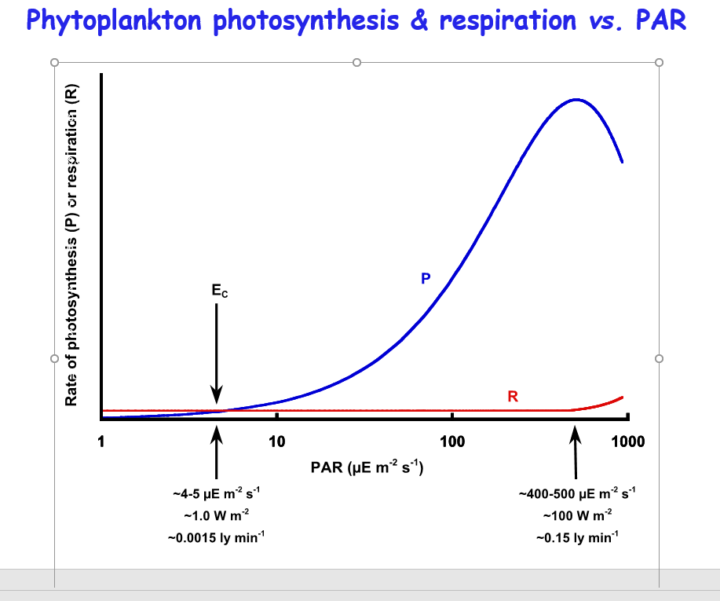

**Question 2**

[*https://www.nature.com/scitable/blog/saltwater-science/what_makes_plankton_migrate/*](https://www.nature.com/scitable/blog/saltwater-science/what_makes_plankton_migrate/)

[*https://prizedwriting.ucdavis.edu/vertical-migration-zooplankton*](https://prizedwriting.ucdavis.edu/vertical-migration-zooplankton)

**Part A**

**Part B**

**Question 3**

[**https://earthobservatory.nasa.gov/features/Phytoplankton**](https://earthobservatory.nasa.gov/features/Phytoplankton)

[**https://earthobservatory.nasa.gov/features/Phytoplankton**](https://earthobservatory.nasa.gov/features/Phytoplankton)

    Organisms generally have three basic needs that include the following:

1. A method to generate ATP
2. An input of elements that can be combined to make macromolecules
3. A source to reduce equivalents
   1. Making more complex organic molecules from oxidized inorganic and simple organic molecules

*Notes*

*Like land plants, phytoplankton have chlorophyll to capture sunlight, and they use photosynthesis to turn it into chemical energy. They consume carbon dioxide, and release oxygen. All phytoplankton photosynthesize, but some get additional energy by consuming other organisms.*

*Phytoplankton growth depends on the availability of carbon dioxide, sunlight, and nutrients. Phytoplankton, like land plants, require nutrients such as nitrate, phosphate, silicate, and calcium at various levels depending on the species. Some phytoplankton can* [*fix nitrogen*](https://earthobservatory.nasa.gov/Glossary/?xref=nitrogen%20fixation) *and can grow in areas where nitrate concentrations are low. They also require trace amounts of iron which limits phytoplankton growth in large areas of the ocean because iron concentrations are very low. Other factors influence phytoplankton growth rates, including water temperature and salinity, water depth, wind, and what kinds of predators are grazing on them.*

*Notes*

How do cells grow in a low nutrient environment?

Uptake mechanisms extremely efficient

Nutrient patches or plumes

Reliance on macroscopic organic aggregates

Types of motility – flagella, others?

Sun

 Water column stratification

 Meridional / Thermohaline circulation

 Water cycle (precip/evapor balance)

 Photoautotrophy

Earth’s rotation

 Atmosphere and Ocean currents

Tides (due to gravitational pull)

Radioactive Decay

 Generation of hydrothermal plumes

NUTRIENT: substance needed for production of new cells (biosynthesis), usually refers to inorganic compounds (ammonium, nitrate, phosphate, silicate, trace metals) required by phytoplankton

SUBSTRATE: compound required by a microbe for growth (either for production of ATP and/or biosynthesis), can refer to inorganic compounds used by phytoplankton or to organic molecules used by heterotrophic bacteria.

For example, ammonium is a compound required by nitrifying Bacteria for ATP production, but most of the N in ammonium is not used for biosynthesis by the nitrifyers.

We would say ammonium is a nutrient for phytoplankton (they use the ammonium for biosynthesis of organic matter).

But, ammonium is a substrate for nitrifying Bacteria, since they mainly use the ammonium as a source of electrons and protons for their ETS in production of ATP.

 Source of chemically reduced inorganic substrates for chemolithotrophs

Smaller organisms grow faster, respire more, and process more food per unit biomass than do larger organisms.  Combining the slight decrease in biomass per unit volume of seawater with the exponential decrease in respiration rate per unit carbon biomass from small to large organisms, it is clear that ocean respiration is mainly due to microbes and the smallest multicellular animals, not to large fish.

*Activity of heterotrophic organisms in the sea:*

*Consumes the organic matter produced by phytoplankton:  on an annual basis, the amount of production and consumption (respiration) of organic matter in the sea just about balances out, with a small net loss to the sediments.*

*[Most primary production is respired, only a small fraction of consumption is used to produce more consumer biomass]*

*Remineralizes (or regenerates) the macro-nutrients: ammonium, nitrate, phosphate, silicate needed for further phytoplankton production*

*Produces food for humans (fish, shellfish)*

[**https://marinebio.org/creatures/zooplankton/**](https://marinebio.org/creatures/zooplankton/)

1) A way to generate ATP, the energy currency of the cell, from ADP +   phosphate (Pi)

    2) A source of elements to make macromolecules, the cell constituents

    3) A source of reducing equivalents: hydrogen atoms (H – proton plus election, or electrons, e-) to make complex organic molecules from more oxidized inorganic and simple organic molecules, (i.e. C-H-N compounds from CO2 and NO3, or biomolecules from sugars and amino acids)

**Evolution of Primary Producers in the Sea**

**Part A**

Reproduction

When you think about grazers you might picture large terrestrial animals grazing on leafy foliage; rarely would you see a grazer eat the whole plant. Plantkon are so small that often a grazer consumes the whole plankton and it is simply gone. To adapt to this phytoplankton have become rapid at reproducing and an often double in number one or more times per day. In the absence of heavy grazing and in favorable conditions (light, temperature and nutrients) you can experience rapid exponential growth.

**Part B**

Biologist belief is that pelagic autotrophs are small because it enables them to have a large surface area in relation to their total biomass. This allows them to absorb nutrients like iron, phosphate and nitrate from a very dilute solution. This nutrient absorption is different and harder for pelagic autotrophs then it is for terrestrial plants and for this plankton where nutrient supply is limited by diffusion from a dilute solution. The small size creates a large relative surface through which diffusion can transport nutrients.

**Part C**

*Functional significance of morphological features?*

*adaptiveness of form is "speculative"*

*e.g. coccoliths*

*Other important ecophysiological features*

*size, volume*

*surface-to-volume ratio*

*morphology and planktonic life*

*floating and sinking*

*nutrient and light requirements*

*grazing pressure*

[*https://earthobservatory.nasa.gov/features/Phytoplankton*](https://earthobservatory.nasa.gov/features/Phytoplankton)

*Species composition*

*Hundreds of thousands of species of phytoplankton live in Earth's oceans, each adapted to particular water conditions. Changes in water clarity, nutrient content, and salinity change the species that live in a given place.*

*Because larger plankton require more nutrients, they have a greater need for the vertical mixing of the water column that restocks depleted nutrients. As the ocean has warmed since the 1950s, it has become increasingly stratified, which cuts off nutrient recycling.*

*Continued warming due to the build up of carbon dioxide is predicted to reduce the amounts of larger phytoplankton such as diatoms), compared to smaller types, like cyanobacteria. Shifts in the relative abundance of larger versus smaller species of phytoplankton have been observed already in places around the world, but whether it will change overall productivity remains uncertain.*

**Question 4**

**Part A**

**Part B**